***Fujinomiya Bulletin***

***May ２０２4***

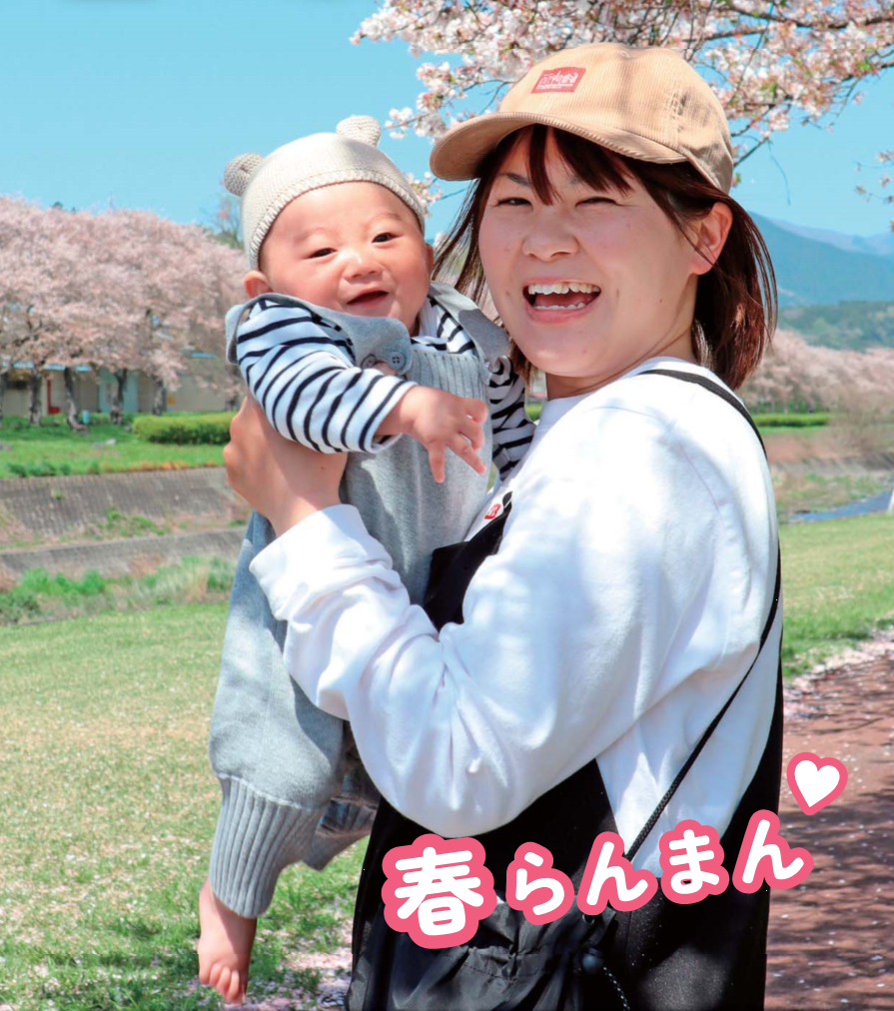

Information on Pregnancy, Children, Childcare

|  |
| --- |
| **If your child get sick suddenly** |
| **Inquiry** Shizuoka Child Emergency Telephone Consultation *(Shizuoka kodomo kyukyu denwa sodan)*  **☎#8000　or 054-247-9910**  **Time** Weekdays 18:00～following 8:00  Saturdays 13:00～following 8:00  Sundays, holidays 8:00～following 8:00  In case of **emergency,** do not hesitate to call **☎119** |

|  |
| --- |
| **If you thought it might be abuse** |
| **Inquiry** Child Guidance Center *(Jido sodan jo)*  Nationwide Common Dial : **☎189** （*Your call will be connected to your nearby Child Guidance Center.）  **Time** 24 hours  **Inquiry** Home and Child Counseling Section, Child Future Division *(kodomo mirai-ka, katei jido sodan-kakari)***☎0544-22-1230**  **Time** Weekdays 8:30～17:15 |

|  |
| --- |
| **Counseling for children with worries** |
| If you have any worries about bullying, truancy, attitude toward life, employment, etc., please consult with us.    **Inquiry** Youth Counseling Center *(Seishonen sodan center)* : **☎0544-22-0064**  Bullying Hotline *(Ijime 110)* : **☎0544-22-1252**  E-mail Counseling : **e-sodan@city.fujinomiya.lg.jp**  **Time** Weekdays 9:00～16:30 (Until 20:00 on the 2nd and 4th Wednesday of each month) |

|  |  |  |  |  |
| --- | --- | --- | --- | --- |
|  | Male | Female | Total | Household |
| Population | 63,327 | 64,231 | 127,558 | 58,973 |
| Month to month basis | (-219) | (-135) | (-354) | (+59) |

**The number of population and households**  (As of April 1st, 2024)

Information on Seniors, Health, Medical Care, Nursing Care, and Disabilities

|  |  |
| --- | --- |
| **Notice** | **<FY2024> Group Medical Checkups** |
| Appointments for group medical checkups will be accepted. Those who had a group medical checkup in FY2023 will be sent the postcard for application.    **Application**  -Mail the postcard for application or visit the city's official website from 9:00 am on May 14 (Tue).  -Please contact us in advance if you have not had a group medical checkup in FY2023 or if you will have it for the first time.  **Inquiry** Health Promotion Division *(Kenko Zoshin-ka)* ☎0544-22-2727    **HP** トップページ＞市民の皆さんへ＞健康・福祉＞健康・医療＞検診 | |



The Japanese fiscal year begins in April and ends in March.

Example:

FY2023 (from April 2023 to March 2024)

FY2024 (from April 2024 to March 2025)

|  |  |
| --- | --- |
| **Notice** | **Group Gynecological Checkups (Breast Cancer / Cervical Cancer)** |
| Cervical cancer is the most common cancer that develops in women and it is increasing among women in their 20s to 40s.  Because this disease is one of the top causes of death, it is important to detect it before symptoms appear and treat it as early as possible.  In group gynecological checkups, cervical and breast cancer screenings are available on the same day.  It is possible to have a cervical cancer screening only.  If you wish to have a breast cancer screening only, please contact us.  **<Those who wish to have both screenings>**  **Eligibility** Women 40 years old and over, and who have not had breast or cervical cancer screening in FY2023.  **Capacity** 60 persons per day (first-come-first-served basis)  **Fee** 2,040 yen  **<Those who wish to have cervical cancer screening only>**  **Eligibility** Women 20 years old and over, and who have not had cervical cancer screening in FY2023.  **Capacity**  20 persons per day (first-come-first-served basis)  **Fee** 1,020 yen (Free for those who will turn 21 years old in FY2024)  **<Common Information>**  **Time** June 21(Fri), July 9(Tue), 24(Wed), August 30(Fri), September 17(Tue), 25(Wed), October 1(Tue), 21(Mon), November 11(Mon), 21(Thu)  **Place** Health Center (*Hoken Center*)/ *Shibakawa Hall *(Shibakawa Kaikan)* on October 1(Tue) only  **Application** From May 16(Thu), By phone or on the city's official website  **Others** -If you have an artificial joint that restricts opening / closing motion, please consult with your doctor before applying.  -If you are on your menstrual period, you may not be able to have a screening. Please avoid around your menstrual period.  -The following persons are not eligible to apply.  □Pregnant  □Breastfeeding / Less than 1 year after weaning / Less than 1 year after postpartum  □Under treatment for breast disease  □Wearing a pacemaker  □Had breast augmentation surgery  □Has a shunt, port, or other tube in the upper body  **Inquiry** Health Promotion Division *(Kenko Zoshin-ka)* ☎0544-22-2727  **HP** トップページ>市民の皆さんへ>健康・福祉>健康・医療>乳がん検診・子宮頸がん検診のお知らせ | |

Information on Events, Applications, Notices, National Insurance, Pensions, Subsidies, Aids, Businesses

|  |  |
| --- | --- |
| **Recruitment** | **Accepting applications for public housing *(shiei jutaku)* tenants** |
| Applications for public housing tenants will be accepted for those who wish to move in July 2024.  **Application** Submit the application form (available on the city's official website) to the counter between May 13 (Mon) to 17 (Fri).  **Inquiry** Building and Housing Division *(Kenchiku Jutaku-ka)*5th floor, City Hall☎0544-22-1163  **HP** トップページ＞市民の皆さんへ＞住まい・ペット・動物＞住まい＞市営住宅入居者募集案内 | |

|  |  |
| --- | --- |
| **Notice** | **Replacement of Water Meter** |
| Water meters that have been installed over 7 years will be replaced free of charge.  A designated water supply equipment installation contractor commissioned by the city will visit in June.  Do not place any objects around the meter box.  **Areas** Aoki, Agoyama, Umamizuka, Kamijo, Shimojo, Shojingawa, Togami, Togami higashi-cho,  Nakahara-cho, Hoshiyama, Miyahara, Yamamoto  **Inquiry** Water Works Division *(Suido Gyomu-ka)* ☎0544-22-1158 | |

**Schedule from May 1st to June 10th**



**■First–aid Medical Treatment Center *(Kyukyu Iryo Center)***

**☎0544-24-9999 / Fax: 0544-24-9995 /** **Address: 12-1 Miyahara, Fujinomiya, Zip Code 418-0005**

|  |  |  |
| --- | --- | --- |
| **Medical treatment subject** | **Day** | **Time** |
| **Internal medicine (*Naika*), Pediatrics (*Shonika*), Surgery (*Geka*)** | Weekdays | 19:00-8:00 on the next day |
| Saturdays | 14:00-8:00 on the next day |
| Sundays, Public holidays,  Year–end and New year holidays | 8:00-8:00 on the next day |
| **Dentistry (*Shika*)** | Sundays, Public holidays,  Year–end and New year holidays | 9:00-17:00  *Reception: until 16:30 |

*If your condition is severe, dial **119** for ambulance. Make sure to bring your **health insurance card** with you.

**■Emergency Ophthalmological Clinics *(Ganka)*** **Open: 9:00-17:00**

*Please make sure to contact the clinics beforehand as they may change.

|  |  |  |
| --- | --- | --- |
| **Date** | **Clinics name/ Address** | **Tel** |
| May 3 | Abe Ganka Iin/ Yunoki Fuji city | 0545-61-5810 |
| May 4 | Asaoka Ganka Iin/ Imaizumi Fuji city | 0545-52-0745 |
| May 5 | Yamamoto Ganka Clinic/ Ishizaka Fuji city | 0545-21-0069 |
| May 6 | Kato Iin/ Hina Fuji city | 0545-34-0011 |
| May 12 | Watanabe Clinic/ Harada Fuji city | 0545-22-1500 |
| May 19 | Ashikawa Hospital/ Chuo-cho Fuji city | 0545-52-2480 |
| May 26 | Nakanishi Ganka Clinic/ Nakano Fuji city | 0545-36-1800 |
| June 2 | Sugiura Ganka/ Kawanarishinmachi Fuji city | 0545-65-8500 |
| June 9 | Hanazaki Ganka Iin/ Aoba-cho Fuji city | 0545-66-0100 |

**■Emergency Obstetrics and Gynecology Clinics *(Sanfujinka)* Open: 9:00-24:00**

*Please make sure to contact the clinics beforehand as they may change.

|  |  |  |
| --- | --- | --- |
| **Date** | **Clinics name/ Address** | **Tel** |
| May 5 | Fujinomiya City General Hospital/ Nishiki-cho | 0544-27-3151 |
| May 12 | Tenjin Sanfujinka Iin/ Wakanomiya-cho | 0544-24-1322 |
| May 19 | Otabe Sanfujinka Iin/ Hibarigaoka | 0544-23-1182 |
| May 26 | Bando Ladies Clinic/ Sugita | 0544-28-5800 |
| June 2 | Fujinomiya City General Hospital/ Nishiki-cho | 0544-27-3151 |
| June 9 | Tenjin Sanfujinka Iin/ Wakanomiya-cho | 0544-24-1322 |

**■Blood Donation**

|  |  |  |
| --- | --- | --- |
| **Date** | **Clinics name/ Address** | **Time** |
| May 3 | AEON Mall Fujinomiya/ Asama-cho | 9:30–16:00* |
| May 6 |
| May 11 |
| May 26 |

*Not implemented from 12:00-13:15.

**Inquiry** Welfare Planning Division *(Fukushi Kikaku-ka)* **☎** 0544-22-1457

■**Due Dates for tax or other payments**

|  |  |
| --- | --- |
| **Date** | **Taxes to be payed** |
| May 7 | Property tax / City planning tax (1st term) |
| May 28 | Water charges, Sewerage charges (for April usage) |
| May 31 | Child care fee (for May usage) |
| Public housing fee / Parking fee (for May usage) |
| June 3 | KEI JIDOSHA tax *Small Cars of Japanese Standard (whole term) |

**■Counseling and Consultation** *Not implemented on public holidays.

**Place: Citizen counselling room, 1st floor, City Hall**

|  |  |
| --- | --- |
| **Consultation** | **Date & Time** |
| 1. General counseling　*(Ippan sodan)* 2. Counseling for non-Japanese residents　*(Gaikokujin sodan)* | Monday-Friday, 8:30-17:00  (*Reception: until 16:30) |
| 1. Counseling on consumer affairs　*(Shohi seikatsu sodan)* | Monday-Friday 9:00-16:00 |
| ④ Attorney　*(Bengoshi sodan)*  *Appointment is required (by 12:00 the day before the consulting day, seats are limited to the first 7 people) | May 1, 8, 15, 22, 29  (13:30- until the end of the consultation) |
| ⑤ Judicial scrivener *(Shihosyoshi sodan)*  *Appointment is required | May 10 13:00-16:00 |
| 1. Licensed tax accountant *(Zeirishi zeimu sodan)*   *Appointment is required | May 7, 21 13:00-15:00 |
| 1. Administrative scrivener *(Gyosei syoshi sodan)* | Not implemented for this month. |
| 1. General administrative counseling *(Gyosei sodan)* | May 9 10:00-15:00 |
| 1. Consultation on the human rights *(Jinken sodan)* | May 21 13:00-16:00 |
| 1. Consultation on side jobs *(Naisyoku assen)* | Mondays and Thursdays 9:00-16:00 |
| 1. Patent attorney　*(Benrishi sodan)* *Appointment is required. | May 24 15:00-17:00 |
| 1. Business start-up consultation *(Sogyo sodan)*   *Appointment is required. | May 28 10:00-15:00 |

①,③-⑨ Community Service Division *(Shimin Seikatsu-ka)*

② Citizen Exchange Division *(Shimin Koryu-ka)*

⑩-⑫ Commerce and Industry Division *(Syoko Shinko-ka)*

**☎** 0544-22-1196

**☎** 0544-22-1246

**☎** 0544-22-1295

**Inquiry**

**Place: Meeting Room 510, 5th Floor, City Hall**

|  |  |
| --- | --- |
| **Consultation** | **Date & Time** |
| Real estate transaction agent *(Takuchi tatemono torihikishi sodan)* | May 14　13:00-15:00 |

**Inquiry** Construction and Housing Division *(Kenchiku Jyutaku-ka)* **☎** 0544-22-1163

**Place: Meeting Room 721, 7th Floor, City Hall**

|  |  |
| --- | --- |
| **Consultation** | **Date & Time** |
| Pension consultation *(Nenkin sodan)* *Appointment is required. | May 23 10:00-15:00 |

**Inquiry** Fuji Pension Office in Fuji city*（Fuji Nenkin Jimusho）* **☎** 0545-61-1900



**富士宮市**

FUJINOMIYA　CITY

■**City Hall Open Days on Holidays:** We open on the first Sunday of each month.

**May 5 (Sun)**

**June 2 (Sun)**

**8:30-17:00**

|  |  |
| --- | --- |
| **Division & Phone number** | **Services** |
| Citizen Registration Division  *(Shimin-ka)*  **☎** 0544-22-1134〈Certification and My Number Card〉  **☎** 0544-22-1135〈Family Register and Address〉 | * Submission for Family Register *(koseki)* (birth, marriage, death, etc.) * Submission of change of residence (moving into the city, moving out of the city, moving within the city, etc.) * Application for seal *(inkan)* registration and abolition * Issuance of various certificates (certificate of residence*(jyuminhyo)*, Family Register*(koseki tohon, koseki syohon)*, certificate of seal*(inkan)* registration) * Receiving passports * Procedures for applying for My Number Card     The services we handle are different from normal days. For details, please call or visit the city's official website. |
| Insurance and Pension Division  *(Hoken Nenkin-ka)*  **☎** 0544-22-1138 | * Qualification and disqualification for National Health Insurance |
| Child Future Division  *(Kodomo Mirai-ka)*  ☎ 0544-22-1146 | * Application for Child Allowance and Child Medical Expense Beneficiary Certificate |
| Tax & Premium Collection Division  *(Shuno-ka)*  ☎ 0544-22-1129〈Payment〉  ☎ 0544-22-1128〈Certification〉 | * Payment of city taxes, etc. and Consultation on payment * Issuance of tax certificates   ※Appointment is required in advance for tax consultation.  ※Tax exemption certificates, etc. that require a declaration cannot be issued |

■**After-hours service: Every Wednesday until 19:00pm**

*No services if a public holiday falls on a Wednesday.

|  |  |
| --- | --- |
| **Division & Phone number** | **Services** |
| Citizen Registration Division  *(Shimin-ka)*  **☎** 0544-22-1134 | * Application for seal *(inkan)* registration and abolition * Issuance of various certificates (certificate of residence*(jyuminhyo)*, family register*(koseki tohon, koseki syohon)*, certificate of seal*(inkan)* registration)     The services we handle are different from normal days. For details, please call or visit the city's official website. |
| Tax & Premium Collection Division  *(Shuno-ka)*  ☎ 0544-22-1129 | * Payment of city taxes, etc. and Consultation on payment * Issuance of tax certificates   ※Appointment is required in advance for tax consultation.  ※Tax exemption certificates, etc. that require a declaration cannot be issued |